GitLab restore commands

1. cd /var/opt/gitlab/backups/

2.  mkdir temp

Cd tmep

3. tar zxvf ../TmTlGit-etc-Mon.tar.gz

4. cat var/opt/gitlab/backups/backup_id



5. mv TmTlGit-Mon.tar <content from above command output>



Folder name with out etc need to take

6.  mv temp/etc/gitlab/gitlab.rb /etc/gitlab/gitlab.rb

7. mv temp/etc/gitlab/gitlab-secrets.json /etc/gitlab/gitlab-secrets.json

8. chmod 777 /var/opt/gitlab/backups/<backup file name>

9. gitlab-ctl stop puma

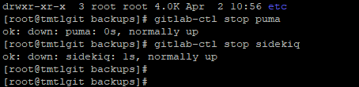

10. gitlab-ctl stop sidekiq

11. gitlab-backup restore BACKUP=1743434418_2025_03_31_13.4.1-ee Note : Backup ID should be extracted from the backup file name.

12. After Restore start above two processes

14. gitlab-rake gitlab:check SANITIZE=true

15. gitlab-rake gitlab:doctor:secrets

16. gitlab-rake gitlab:artifacts:check

17. gitlab-rake gitlab:lfs:check

18. gitlab-rake gitlab:uploads:check

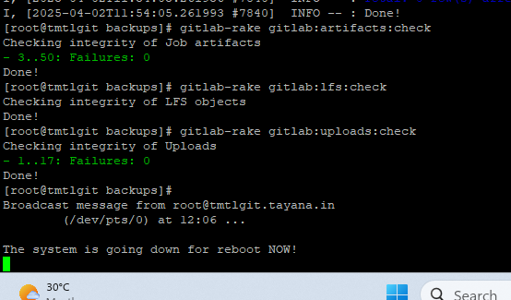

19. Enter the database console.

  Run the following:  
  SQL  
  SET STATEMENT_TIMEOUT=0 ; ANALYZE VERBOSE;